December 30, 2024

***Sent Via Email to: VIA_TYPE_CINS***

CINS

Attn: CLAIM_RESPONSIBLE_RECEIVER

Claims Department

**Re: FORMAL DEMAND FOR UNDERINSURED MOTORIST ARBITRATION OUR CLIENT : CLIENT_NAME_ALL_CAP**

**TORTFEASOR : INSURED_NAME_ALL_CAP**

**YOUR CLAIM NO. : CLAIM_NUMBER**

**YOUR POLICY NO. : POLICY_NUMBER**

**DATE OF LOSS : DATE_OF_LOSS**

To Whom It May Concern:

This firm represents the interests of CINS’s insured, and my client, MR_MRS_CLIENT_LAST_NAME (hereinafter referred to as “MR_MRS_CLIENT_LAST_NAME” and/or “Client’), whom was injured in an automobile vs. automobile collision on DATE_OF_LOSS_FORMATTED, with respect to injuries and damages sustained in the above-referenced accident.

Please allow this letter to serve as our client’s **FORMAL DEMAND FOR UNINSURED/UNDERINSURED MOTORIST ARBITRATION** pursuant to the provisions of the above-referenced automobile policy which our client, MR_MRS_CLIENT_LAST_NAME, maintained with your company, CINS, at the time of the above referenced loss.

An executed declaration by the undersigned in support of MR_MRS_CLIENT_LAST_NAME’s herein Formal Demand for Underinsured Motorist Arbitration is set forth below for your reference and file.

Kindly forward this matter to counsel for further handling and notify the handling adjuster of same.

Additionally, we kindly request that the handling claims adjuster at CINS forward a full and complete legible copy of our client’s automobile insurance policy, including the provisions for Underinsured Motorist Arbitration, to this office upon receipt of this request, and by no later than 15 calendar days from the date of this correspondence.

Furthermore, please notify this office within 15 calendar days from the date of this letter, in writing, of the name and contact information of CINS’s retained legal counsel assigned to represent your company in this Underinsured Motorist Arbitration matter moving forward.

Unless written notice of CINS’s assigned legal counsel representing your company’s interests in this matter is received by this office, all further communications, including any and all written discovery requests and/or other pleadings will be submitted to you directly for response.

Thank you for your prompt attention to this matter.

**DECLARATION OF LILLIAN SEDAGHAT**

I, LILLIAN SEDAGHAT, do hereby declare as follows:

I am an attorney duly licensed to practice before all Courts of the State of California and am employed as an attorney with Sedaghat Law Group, APC, counsel of record for Claimant, CLIENT_NAME_EACH_CAP (hereinafter referred to herein as “Claimant”), in the instant action.

In support of Claimant’s **FORMAL DEMAND FOR UNDERINSURED MOTORIST ARBITRATION** served herewith, I state the following under penalty of perjury upon information and belief unless stated otherwise:

* 1. The claimant does not have a related Worker’s Compensation claim.
  2. Claimant’s claim has not proceeded to findings and award.
  3. Claimant has settled his claims with the third-party insurer for applicable policy limits and Claimant’s damages nevertheless exceed said limits, necessitating the herein claim and demand for underinsured motorist arbitration.

DATED: 09/10/2024

Very Truly Yours,

**SEDAGHAT LAW GROUP**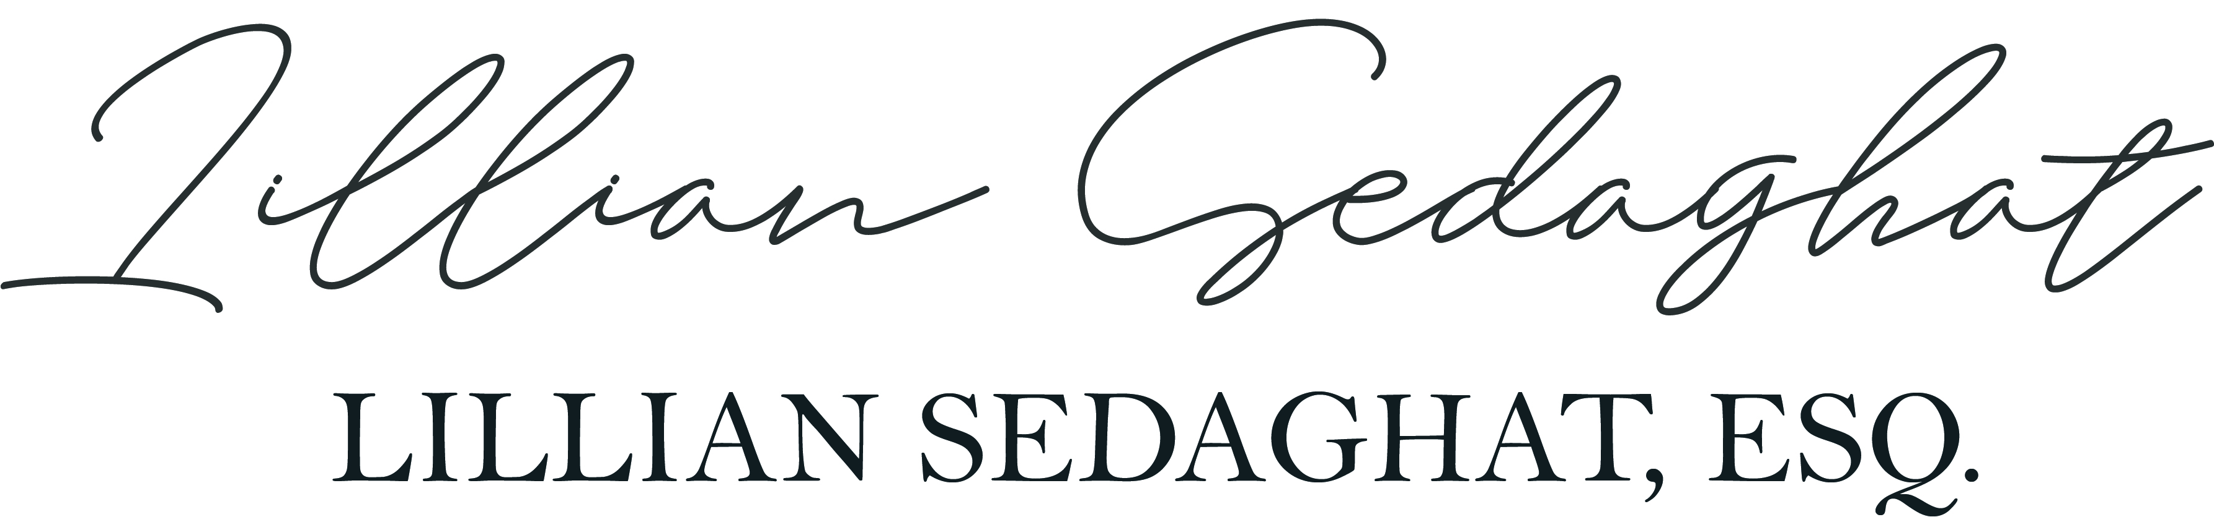

Managing Partner